ADS1- STATISTICS AND TRENDS

Name : Aadhithiyan Kalaivani Viswanathan

University ID : 22082768

Github Link : <https://github.com/Aadhivisu/ADS1.git>

DataSet Link : https://data.worldbank.org/topic/climate-change

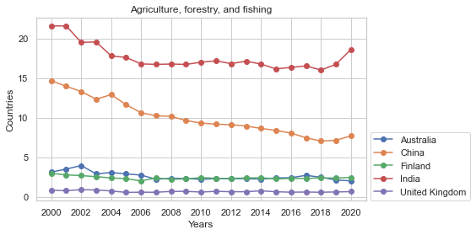

The line plot showcases the percentage of GDP generated from agriculture, forestry, and fishing sectors in five countries between 2000 and 2020. The United Kingdom's share of GDP from the agriculture sector has been decreasing since 2000. China and India have consistently increased their shares of GDP from the agriculture sector, indicating that these two countries have successfully invested in and developed their agricultural sectors to ensure food security and promote sustainable development. In comparison, Australia and Finland have maintained a relatively stable share of GDP from the agriculture sector. However, Finland's share of GDP from agriculture has been declining over time, implying that Finland may be prioritizing non-agricultural sectors for economic growth.

|  |  |
| --- | --- |
|  | **The accomplishment of universal electricity access in these nations is a testament to the potential for equitable electricity distribution worldwide. Through the implementation of effective strategies, optimal utilization of available resources, and investment in innovative technologies, these countries have successfully ensured that all their citizens have access to dependable electricity services. These achievements highlight the progress made by these countries in their pursuit of universal electricity access. By adopting similar approaches, leveraging available resources, and embracing innovative technologies, other nations can strive towards bridging the electricity access gap and providing equitable and inclusive electricity services for all.As the world's largest electricity consumer, over 95% of citizens now enjoy electricity availability, a testament to world's commendable efforts in this regards.** |

The data given by the United Nations and World Bank Research shows intriguing patterns of CO2 emissions and the availability of arable land among various nations. By comparing the CO2 emissions and arable land data from 2000 to 2020, we can observe that China, India, and Finland made notable improvements in reducing CO2 emissions and preserving their arable land, while Australia, the United Kingdom, and Finland saw a decline in arable land. It is interesting to note that India and United Kingdom have taken significant steps to reduce their greenhouse gas emissions and promote renewable energy sources.

|  |  |
| --- | --- |
|  |  |

**Both countries have implemented policies and strategies to mitigate their emissions, with China adopting a mix of strategies and India prioritizing renewable energy sources. While they have shown progress in reducing their emissions and promoting sustainable development, they still face challenges such as expanding their renewable energy capacities, enhancing energy efficiency, and addressing issues related to deforestation and water scarcity.**

In conclusion, India's economic growth between 2005 and 2010 resulted in a greater increase in CO2 emissions per PPP dollar of GDP compared to China. While this increase may seem concerning, it is important to note that China's per capita GDP has grown significantly during this period, contributing to its overall emissions growth. Additionally, considering factors such as deforestation and water scarcity adds complexity to the relationship between economic growth and CO2 emissions. It is also crucial to remember that while CO2 emissions are a key indicator of greenhouse gas emissions, other pollutants such as nitrous oxide and methane also contribute to global warming. Therefore, the comparison of CO2 emissions per PPP dollar of GDP between India and China is only one aspect of understanding their economic growth and emissions reduction efforts.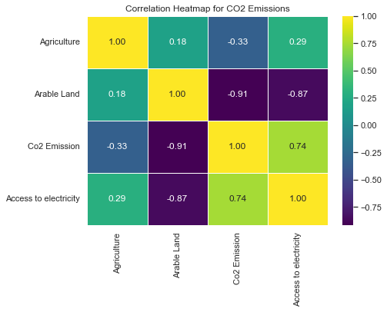

**Conclusion** : The measurement of CO2 emissions is a crucial parameter in assessing both the economic development and environmental responsibility of nations.. Moreover, there exists substantial potential for growth within sectors like Arable Land and Agriculture, Forestry, and Fishing value added relative to GDP. This expansion can lead to enhanced productivity levels alongside diminished carbon footprints. By thoroughly analyzing these pivotal elements and their interconnections, policy-makers are empowered to make well-informed choices that propel economic progress while simultaneously mitigating climate change-related hazards.